Exhibition Checklist
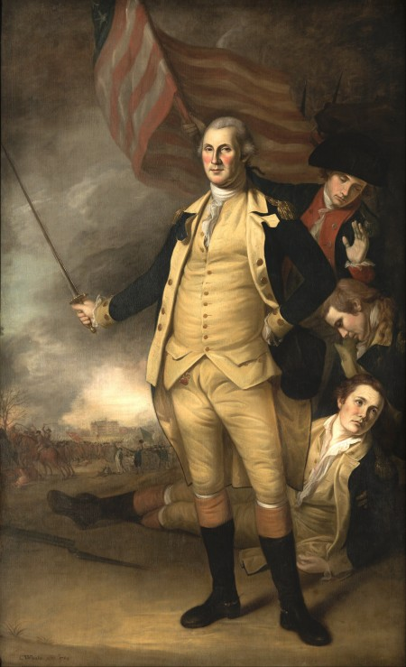 | Details  - Title: Portrait of George Washington after the battle of Princeton  - Creator: Charles Willson Peale.  - Date: ca. 1783  - Physical Dimensions: 95 x 61 in. (241.3 x 154.9 cm) framed: 102 x 68 x 4 in. (259.1 x 172.7 x 10.2 cm)  - Medium: Oil on canvas
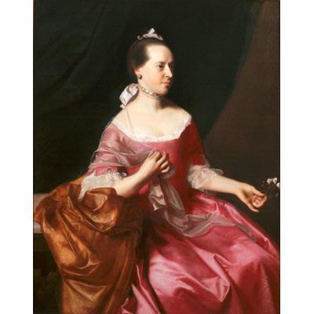 | Details  - Title: Portrait of Mrs. Joseph Scott  - Creator: John Singleton Copley  - Date: ca. 1765  - Location: Newark Museum (United States - Newark, New Jersey)  - Physical Dimensions: w40 x h50 in (Image)  - Provenance: Purchase 1948 The Members' Fund  - Type: Painting  - Rights: http://www.newarkmuseum.org/terms.html  - External Link: Newark Museum  - Medium: Oil on canvas
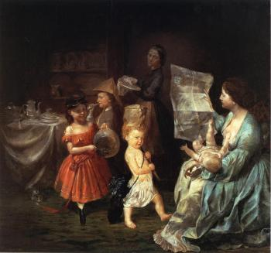 | Details  Title: The War Spirit at Home: Celebrating the Battle at Vicksburg  Artist: Lilly Martin Spencer
  Dates: | 1866
  Location: | Newark Museum (United States - Newark, New Jersey)
  Dimensions: | Height: 76.2 cm (30 in.), Width: 83.19 cm (32.75 in.)
  Medium: | Painting - oil on canvas
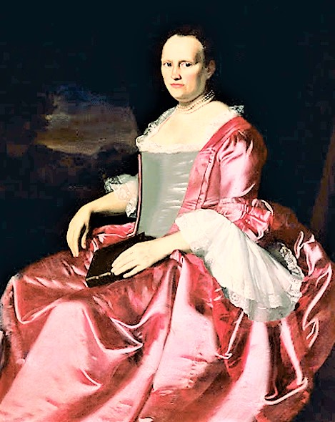 | Details  Title: Portrait of Elizabeth Allen Stevens  Artist: John Singleton Copley  Date: ca. 1757  Location: Newark Museum (United States - Newark, New Jersey)  Physical Dimensions: w40 x h50 in (Image)  Provenance: Purchase 1948 The Members' Fund  Type: Painting  Rights: http://www.newarkmuseum.org/terms.html  External Link: Newark Museum  Medium: Oil on canvas

